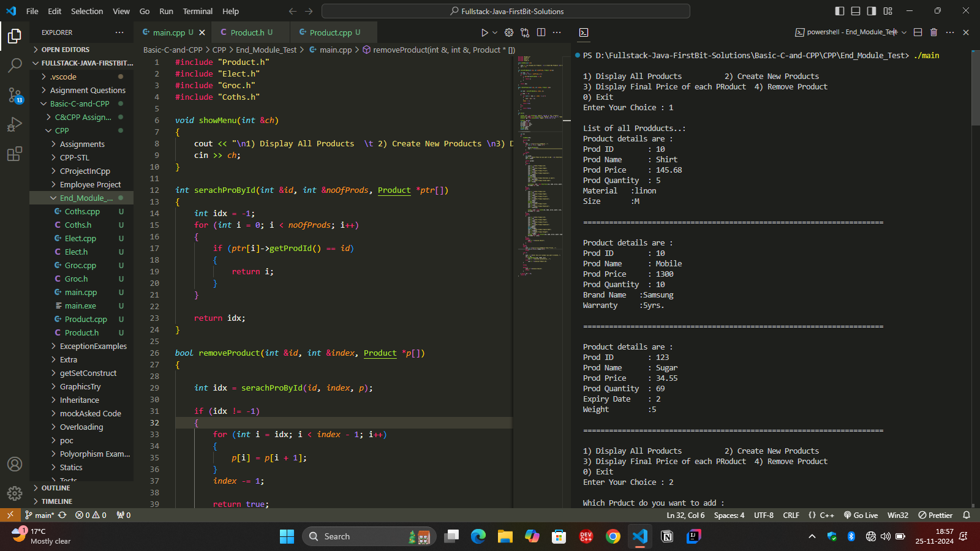

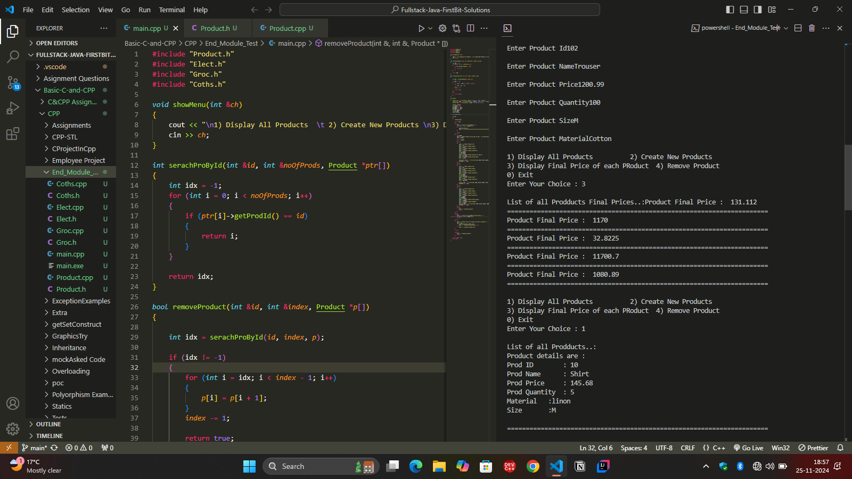

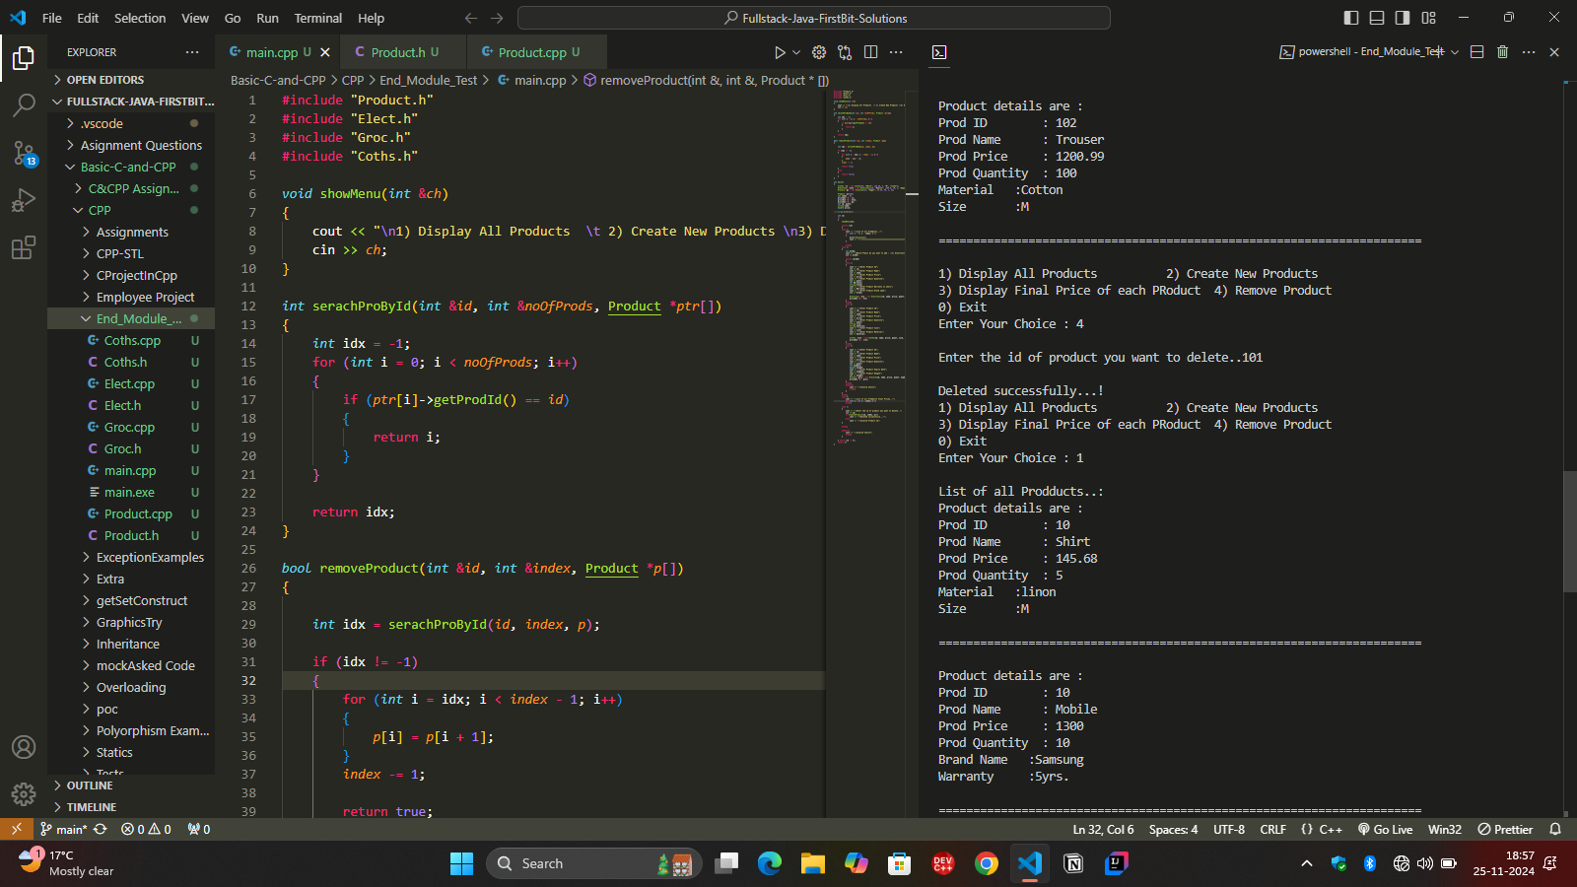

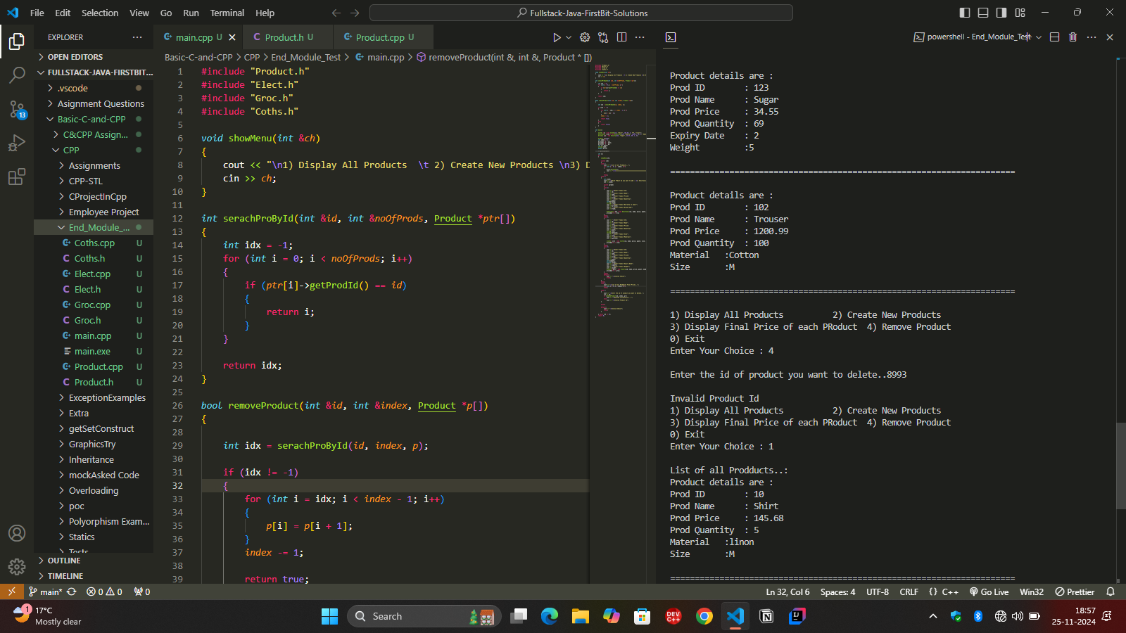

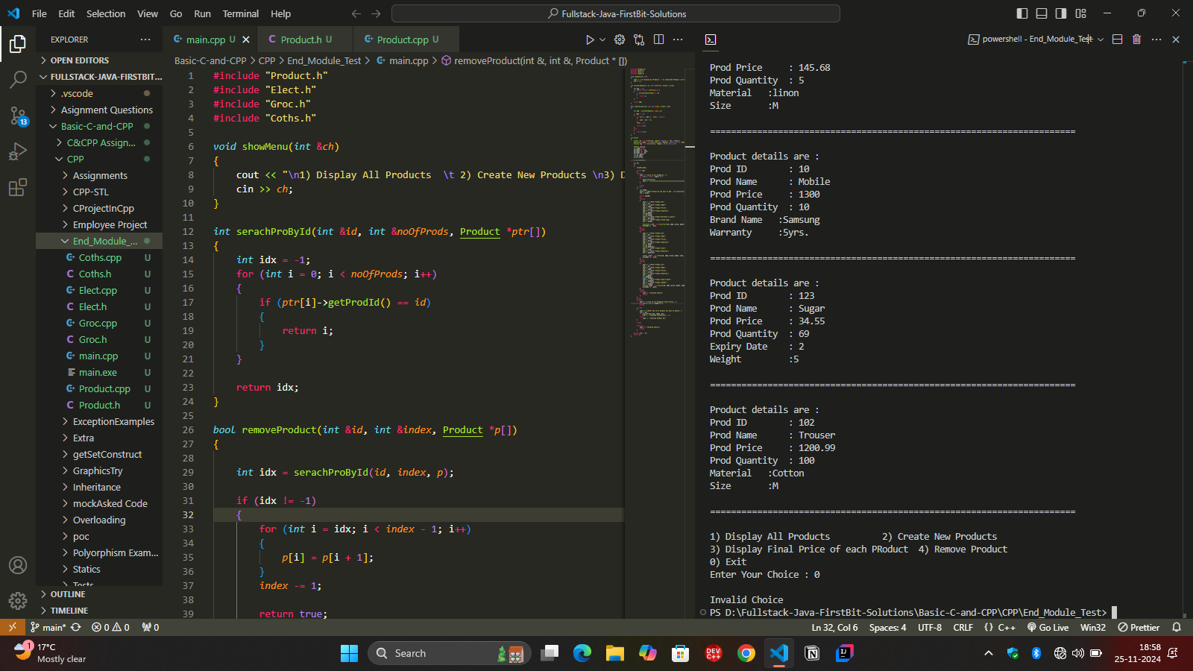

PS D:\Fullstack-Java-FirstBit-Solutions\Basic-C-and-CPP\CPP\End_Module_Test> ./main

1) Display All Products 2) Create New Products

3) Display Final Price of each PRoduct 4) Remove Product

0) Exit

Enter Your Choice : 1

List of all Prodducts..:

Product details are :

Prod ID : 10

Prod Name : Shirt

Prod Price : 145.68

Prod Quantity : 5

Material :linon

Size :M

======================================================================

Product details are :

Prod ID : 10

Prod Name : Mobile

Prod Price : 1300

Prod Quantity : 10

Brand Name :Samsung

Warranty :5yrs.

======================================================================

Product details are :

Prod ID : 123

Prod Name : Sugar

Prod Price : 34.55

Prod Quantity : 69

Expiry Date : 2

Weight :5

======================================================================

1) Display All Products 2) Create New Products

3) Display Final Price of each PRoduct 4) Remove Product

0) Exit

Enter Your Choice : 2

Which Prduct do you want to add :

1) Electronics 2) Cloth 3) Grocery

1

Enter Product Id101

Enter Product NameLaptop

Enter Product Price13000.78

Enter Product Quantity12

Enter Product Warranty in years5

Enter Product Brand nameDell

1) Display All Products 2) Create New Products

3) Display Final Price of each PRoduct 4) Remove Product

0) Exit

Enter Your Choice : 2

Which Prduct do you want to add :

1) Electronics 2) Cloth 3) Grocery

2

Enter Product Id102

Enter Product NameTrouser

Enter Product Price1200.99

Enter Product Quantity100

Enter Product SizeM

Enter Product MaterialCotton

1) Display All Products 2) Create New Products

3) Display Final Price of each PRoduct 4) Remove Product

0) Exit

Enter Your Choice : 3

List of all Prodducts Final Prices..:Product Final Price : 131.112

======================================================================

Product Final Price : 1170

======================================================================

Product Final Price : 32.8225

======================================================================

Product Final Price : 11700.7

======================================================================

Product Final Price : 1080.89

======================================================================

1) Display All Products 2) Create New Products

3) Display Final Price of each PRoduct 4) Remove Product

0) Exit

Enter Your Choice : 1

List of all Prodducts..:

Product details are :

Prod ID : 10

Prod Name : Shirt

Prod Price : 145.68

Prod Quantity : 5

Material :linon

Size :M

======================================================================

Product details are :

Prod ID : 10

Prod Name : Mobile

Prod Price : 1300

Prod Quantity : 10

Brand Name :Samsung

Warranty :5yrs.

======================================================================

Product details are :

Prod ID : 123

Prod Name : Sugar

Prod Price : 34.55

Prod Quantity : 69

Expiry Date : 2

Weight :5

======================================================================

Product details are :

Prod ID : 101

Prod Name : Laptop

Prod Price : 13000.8

Prod Quantity : 12

Brand Name :Dell

Warranty :5yrs.

======================================================================

Product details are :

Prod ID : 102

Prod Name : Trouser

Prod Price : 1200.99

Prod Quantity : 100

Material :Cotton

Size :M

======================================================================

1) Display All Products 2) Create New Products

3) Display Final Price of each PRoduct 4) Remove Product

0) Exit

Enter Your Choice : 4

Enter the id of product you want to delete..101

Deleted successfully...!

1) Display All Products 2) Create New Products

3) Display Final Price of each PRoduct 4) Remove Product

0) Exit

Enter Your Choice : 1

List of all Prodducts..:

Product details are :

Prod ID : 10

Prod Name : Shirt

Prod Price : 145.68

Prod Quantity : 5

Material :linon

Size :M

======================================================================

Product details are :

Prod ID : 10

Prod Name : Mobile

Prod Price : 1300

Prod Quantity : 10

Brand Name :Samsung

Warranty :5yrs.

======================================================================

Product details are :

Prod ID : 123

Prod Name : Sugar

Prod Price : 34.55

Prod Quantity : 69

Expiry Date : 2

Weight :5

======================================================================

Product details are :

Prod ID : 102

Prod Name : Trouser

Prod Price : 1200.99

Prod Quantity : 100

Material :Cotton

Size :M

======================================================================

1) Display All Products 2) Create New Products

3) Display Final Price of each PRoduct 4) Remove Product

0) Exit

Enter Your Choice : 4

Enter the id of product you want to delete..8993

Invalid Product Id

1) Display All Products 2) Create New Products

3) Display Final Price of each PRoduct 4) Remove Product

0) Exit

Enter Your Choice : 1

List of all Prodducts..:

Product details are :

Prod ID : 10

Prod Name : Shirt

Prod Price : 145.68

Prod Quantity : 5

Material :linon

Size :M

======================================================================

Product details are :

Prod ID : 10

Prod Name : Mobile

Prod Price : 1300

Prod Quantity : 10

Brand Name :Samsung

Warranty :5yrs.

======================================================================

Product details are :

Prod ID : 123

Prod Name : Sugar

Prod Price : 34.55

Prod Quantity : 69

Expiry Date : 2

Weight :5

======================================================================

Product details are :

Prod ID : 102

Prod Name : Trouser

Prod Price : 1200.99

Prod Quantity : 100

Material :Cotton

Size :M

======================================================================

1) Display All Products 2) Create New Products

3) Display Final Price of each PRoduct 4) Remove Product

0) Exit

Enter Your Choice : 0

Invalid Choice

PS D:\Fullstack-Java-FirstBit-Solutions\Basic-C-and-CPP\CPP\End_Module_Test>

**Main.cpp**

#include "Product.h"

#include "Elect.h"

#include "Groc.h"

#include "Coths.h"

*void* showMenu(*int* &*ch*)

{

    cout << "\n1) Display All Products  \t 2) Create New Products \n3) Display Final Price of each PRoduct\t4) Remove Product \n0) Exit\nEnter Your Choice : ";

    cin >> *ch*;

}

*int* serachProById(*int* &*id*, *int* &*noOfProds*, Product \**ptr*[])

{

*int* idx = -1;

    for (*int* i = 0; i < *noOfProds*; i++)

    {

        if (*ptr*[i]->getProdId() == *id*)

        {

            return i;

        }

    }

    return idx;

}

*bool* removeProduct(*int* &*id*, *int* &*index*, Product \**p*[])

{

*int* idx = serachProById(*id*, *index*, *p*);

    if (idx != -1)

    {

        for (*int* i = idx; i < *index* - 1; i++)

        {

*p*[i] = *p*[i + 1];

        }

*index* -= 1;

        return true;

    }

    else

    {

        return false;

    }

}

*int* main()

{

    Cloths *c1 = new Cloths(10, "Shirt", 145.68, 5, "M", "linon");

    Electronic *ele1 = new Electronic(10, "Mobile", 1300.0, 10, 5, "Samsung");

    Grocery *g1 = new Grocery(123, "Sugar", 34.55, 69, 2, 5);

    Product *pr[10];

*int* index = 0;

    pr[index++] = c1;

    pr[index++] = ele1;

    pr[index++] = g1;

*int* id, quant;

    string name;

*double* price;

    // g1.display();

    // cout << "Discounted Price : " << g1.calculateDiscountedPrice();

    // ele1.display();

    // cout << "Discounted Price : " << ele1.calculateDiscountedPrice();

    // c1.display();

    // cout << "Discounted Price : " << c1.calculateDiscountedPrice();

*int* ch;

    do

    {

        showMenu(ch);

        switch (ch)

        {

        case 1:

            cout << "\nList of all Prodducts..:";

            for (*int* i = 0; i < index; i++)

            {

                pr[i]->display();

                cout << "\n\n======================================================================\n";

            }

            break;

        case 2:

        {

*int* prodC;

            cout << "\nWhich Prduct do you want to add : \n1) Electronics \t2) Cloth \t 3) Grocery \n";

            cin >> prodC;

            switch (prodC)

            {

            case 1:

            {

                cout << "\nEnter Product Id";

                cin >> id;

                cout << "\nEnter Product Name";

                cin >> name;

                cout << "\nEnter Product Price";

                cin >> price;

                cout << "\nEnter Product Quantity";

                cin >> quant;

*int* Warranty;

                string brand;

                cout << "\nEnter Product Warranty in years";

                cin >> Warranty;

                cout << "\nEnter Product Brand name";

                cin >> brand;

                Electronic *ele = new Electronic(id, name, price, quant, Warranty, brand);

                pr[index++] = ele;

            }

            break;

            case 2:

            {

                cout << "\nEnter Product Id";

                cin >> id;

                cout << "\nEnter Product Name";

                cin >> name;

                cout << "\nEnter Product Price";

                cin >> price;

                cout << "\nEnter Product Quantity";

                cin >> quant;

                string size;

                string material;

                cout << "\nEnter Product Size";

                cin >> size;

                cout << "\nEnter Product Material";

                cin >> material;

                Cloths *clot = new Cloths(id, name, price, quant, size, material);

                pr[index++] = clot;

            }

            break;

            case 3:

            {

                cout << "\nEnter Product Id";

                cin >> id;

                cout << "\nEnter Product Name";

                cin >> name;

                cout << "\nEnter Product Price";

                cin >> price;

                cout << "\nEnter Product Quantity";

                cin >> quant;

*int* expdate;

*double* weight;

                cout << "\nEnter Product Expiry Date";

                cin >> expdate;

                cout << "\nEnter Product Weight";

                cin >> weight;

                Grocery *groc = new Grocery(id, name, price, quant, expdate, weight);

                pr[index++] = groc;

            }

            break;

            default:

                cout << "\nInvalid Choice";

                break;

            }

        }

        break;

        case 3:

            cout << "\nList of all Prodducts Final Prices..:";

            for (*int* i = 0; i < index; i++)

            {

                pr[i]->calculateDiscountedPrice();

                cout << "Product Final Price :  " << pr[i]->getFPrice();

                cout << "\n======================================================================\n";

            }

            break;

        case 4:

        {

            cout << "\nEnter the id of product you want to delete..";

            cin >> id;

            if (removeProduct(id, index, pr))

                cout << "\nDeleted successfully...!";

            else

                cout << "\nInvalid Product Id";

        }

        break;

        default:

            cout << "\nInvalid Choice";

            break;

        }

    } while (ch != 0);

    return 0;

}

**Product.h**

#include <bits/stdc++.h>

using *namespace* std;

#pragma once

*class* Product

{

*int* prodId;

    string prodName;

*double* prodPrice, finalPrice;

*int* prodQuantity;

*public:*

    Product(*int*, string);

    Product(*int*, string, *double*, *int*);

*void* setPrice(*double*);

*double* getPrice();

*void* setFPrice(*double*);

*double* getFPrice();

*int* getProdId();

    virtual *void* display();

    virtual *double* calculateDiscountedPrice()=0;

};

**Product.cpp**

#include "Product.h"

Product::Product(*int* *id*, string *name*)

{

    this->prodId = *id*;

    this->prodName = *name*;

}

Product::Product(*int* *id*, string *name*, *double* *price*, *int* *quant*)

{

    this->prodId = *id*;

    this->prodName = *name*;

    this->prodPrice = *price*;

    this->prodQuantity = *quant*;

}

*void* Product::setPrice(*double* *price*)

{

    this->prodPrice = *price*;

}

*double* Product::getPrice()

{

    return this->prodPrice;

}

*void* Product::setFPrice(*double* *price*)

{

    this->finalPrice = *price*;

}

*double* Product::getFPrice()

{

    return this->finalPrice;

}

*int* Product::getProdId()

{

    return this->prodId;

}

*void* Product::display()

{

    cout << "\nProduct details are :";

    cout << "\nProd ID        : " << this->prodId;

    cout << "\nProd Name      : " << this->prodName;

    cout << "\nProd Price     : " << this->prodPrice;

    cout << "\nProd Quantity  : " << this->prodQuantity;

}

**Elect.h**

#include "Product.h"

*class* Electronic :*public* Product

{

*int* warranty;

    string brand;

*public:*

    Electronic(*int*, string, *double*, *int*, *int*, string);

*void* display();

    // void setName(string);

    // void setWarranty(int);

    // void setBrand(string);

*double* calculateDiscountedPrice() override;

    // void setPrice(double);

};

**Elect.cpp**

#include "Elect.h"

Electronic::Electronic(*int* *id*, string *name*, *double* *price*, *int* *quant*, *int* *warranty*, string *brand*) : Product(*id*, *name*, *price*, *quant*)

{

    this->brand = *brand*;

    this->warranty = *warranty*;

}

*void* Electronic::display()

{

    Product::display();

    cout << "\nBrand Name   :" << this->brand;

    cout << "\nWarranty     :" << this->warranty << "yrs.";

}

*double* Electronic::calculateDiscountedPrice()

{

*double* discount = 0.10;

    this->setFPrice(this->getPrice() - (this->getPrice() * discount));

    return this->getFPrice();

}

**Groc.h**

#include "Product.h"

*class* Grocery :*public* Product

{

*int* expDate;

*double* weight;

*public:*

    Grocery(*int*, string, *double*, *int*, *int*, *double*);

*void* display();

*double* calculateDiscountedPrice() override;

};

**Groc.cpp**

#include "Groc.h"

Grocery::Grocery(*int* *id*, string *name*, *double* *price*, *int* *quant*, *int* *expDate*, *double* *weight*) : Product(*id*, *name*, *price*, *quant*)

{

    this->expDate = *expDate*;

    this->weight = *weight*;

}

*void* Grocery::display()

{

    Product::display();

    cout << "\nExpiry Date    : " << this->expDate;

    cout << "\nWeight         :" << this->weight;

}

*double* Grocery::calculateDiscountedPrice()

{

*double* discount = 0.05;

    this->setFPrice(this->getPrice() - (this->getPrice() * discount));

    return this->getFPrice();

}

**Coths.h**

#include "Product.h"

*class* Cloths : *public* Product

{

    string size;

    string material;

*public:*

    Cloths(*int*, string, *double*, *int*, string, string);

*void* display();

*double* calculateDiscountedPrice() override;

};

**Coths.cpp**

#include "Coths.h"

Cloths::Cloths(*int* id, string name, *double* price, *int* quant, string size, string material) : Product(id, name, price, quant)

{

    this->material = material;

    this->size = size;

}

*void* Cloths::display()

{

    Product::display();

    cout << "\nMaterial   :" << this->material;

    cout << "\nSize       :" << this->size;

}

*double* Cloths::calculateDiscountedPrice()

{

*double* discount = 0.10;

    this->setFPrice(this->getPrice() - (this->getPrice() * discount));

    return this->getFPrice();

}